**Research Strategy**

**1. Significance**

**What is the problem?** Autism spectrum disorder (ASD) impacts about 1 in 36 children in the U.S., characterized by social and other behavioral challenges (cdc.gov). Large-scale genetic studies have revealed that *SCN2A* is one of the most frequently mutated genes in patients with ASD1,2. *SCN2A* gene encodes for NaV1.2, which is a vital voltage-gated sodium channel in the central nervous system, supporting action potential firing. Thus, **studying neuronal dysfunction is key to understanding the role of *SCN2A* in autism**. Most *SCN2A* mutations identified in ASD are loss-of-function, and currently, there is no cure for *SCN2A*-linked ASD3. Here,I will use *SCN2A-C959X,* a nonsense mutation to study *SCN2A* deficiency-associated autism. **The *C959X* mutation is selected because it is associated with severe autism in the clinic1 and triggers nonsense-mediated decay, leading to a complete loss of function, which accounts for 18 out of 47 loss-of-function cases in a recent study**4. Since impaired sociability is a central hallmark of autism5, and the cortico-striatal circuitry plays a key role in social and repetitive behaviors6-8, thus **understanding how *SCN2A* deficiency disrupts this circuit is crucial to unraveling its impact on autistic-like phenotypes.** Additionally, *SCN2A* is predominantly expressed in principal neurons within the cortico-striatal circuitry9, making it a critical focus for autism research.

**What has been done? (The rigor of prior research)**.**What is the gap that remains and how do you** **propose to address the gap?** Prior research on canonical *Scn2a* knockout mouse models revealed that homozygous (HOM) null mice perish perinatally, while **heterozygous (HET) mice exhibit no major social impairments**10-14, **failing to replicate the autistic phenotypes seen in patients with *SCN2A-HET* mutations**, indicating a gap caused by species differences in neuronal and circuit function and underling gene expression profiles. To address it, I chose derived 3D human organoids/assembloids as a more relevant model. 3D organoids15,16 offer superior structural complexity, network maturity, and microenvironments, unlike 2D models, which are limited by immature synaptic development17,18. Thus, my aim 1 is to study how *SCN2A* deficiency impacts neuronal function in the 3D human organoids**.** Research shows that cortico-striatal projections are disrupted in both experimental ASD models and individuals with ASD6,8,19-22. Imaging studies reveal mixed findings in rodent models, with both hyper- and hypo-connectivity reported across different brain regions8,19. However, most cellular-level studies in rodent models indicate that cortico-striatal projections tend to be depressed in ASD6,19 8,21, suggesting impaired communication between the cortex and striatum contributes to autism-related behaviors. These mixed findings highlight the complexity of connectivity changes in ASD and underscore the need for further investigation. To address this, I created human cortical-striatal 'assembloids' *in vitro* to model the key circuitry involved in ASD23-26 and examine how *SCN2A* deficiency impairs the key circuitry. **My central hypothesis is** **that *SCN2A deficiency leads to a pathogenic cascade from intrinsic neuronal hyperexcitability to impaired axon projections and decreased synaptic functions that produce an ASD-relevant deficit in brain cortico-striatal circuits (Fig. 1).* Figure 1** illustrates the proposed mechanism for studying *SCN2A* in the **cortical-striatal circuitry**. In early development, **NaV1.2** is present in **axons and axon initial segments (AIS)**, where it plays a crucial role in **initiating and propagating action potentials27,28**. This led me to study: **1)** measuring **intrinsic neuronal excitability** via action potentials and AIS length, and **2)** analyzing **axon projections** within the cortico-striatal circuit. In later stages, NaV1.2 expression shifts to soma and dendrites29,30, leading to **3)** an assessment of **network excitability** and **synaptic properties**. Additionally, I will use **chimeric brains** to investigate cortico-striatal circuit’s function associated with autism-like behaviors. **Figure 2** provides a detailed overview of the proposed experimental design for this proposal.

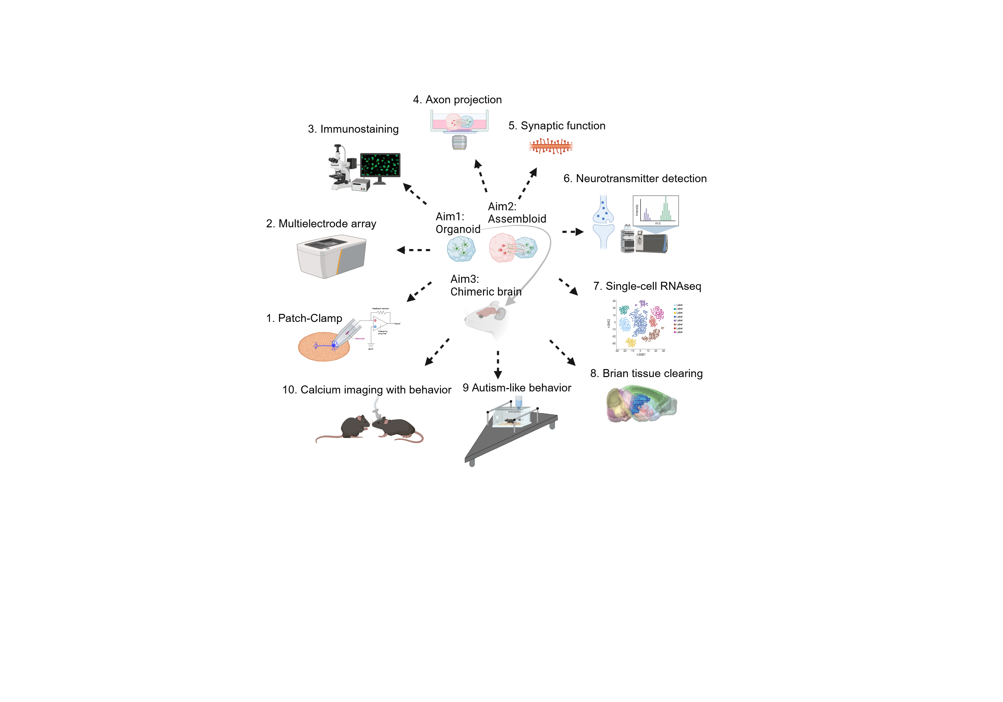**Fig. 2.** P**roposed experimental design.**

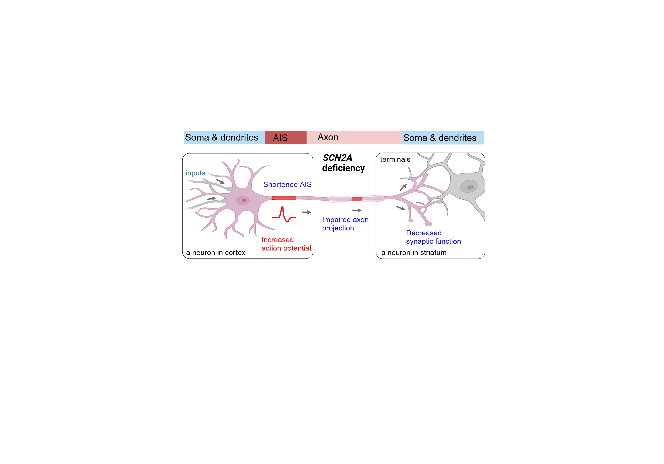 **Fig. 1. Proposed mechanism for *SCN2A* function in cortico-striatal circuitry.** *SCN2A* deficiency leads to a pathogenic cascade from increased neuronal excitability with shortened AIS to impaired axon projections and decreased synaptic functions that produce ASD-relevant deficits in brain cortico-striatalcircuits. **(new)**

**Potential Impact:** (1) ***SCN2A*-related ASD**: Studying *SCN2A* deficiency, a leading monogenetic form of ASD, offers new insights into autism mechanisms. (2) **Brain circuitry**: By using human assembloids and chimeric brain models, I deepen our understanding of circuits underlying social behavior. (3) **Clinical relevance**: compare with rodent models, organoids/assembloids and chimeric models with human biology unveil the potential for identifying both convergent and divergent alterations, improving the translational potential for autism treatment.

# 2. Innovation

# My conceptually innovative study design, combined with novel technologies, enables us to generate rigorous, reproducible results to understand the cellular and circuit mechanisms underlying *SCN2A* deficiency in a human context. Key innovations include 1) the use of human-context models (cortical and striatal organoids, cortical-striatal assembloids) to study *SCN2A* deficiency in autism, 2) the first application of human-mouse chimeric brains for *in vivo* study of neural activity and autism-like behaviors in *SCN2A* filed, and 3) a comprehensive toolkit incorporating advanced technologies like electrochemical detection, brain tissue-clearing, and scRNA sequencing. While these methods are established, applying them to the *SCN2A* field offers fresh insights and new research avenues for ASD.

**3. Approach**

**Aim 1 (K99 phase): Determine dysfunctions of neurons in** **human organoids** **with *SCN2A* deficiency.**

**Preliminary data**

1. Successful generation and characterization of human brain cortical and striatal organoids.

To better emulate the human neural structure and network maturity, I optimized the protocols to successfully generate human cortical spheroid (hCS), and human striatal spheroid (hStrS)31,32 (**Fig. 3A, B**) from hiPSCs and confirmed their specificity via immunostaining. hCS expressed neuronal markers CTIP2, TBR1, MAP2, and NEUN, while hStrS showed GABAergic markers GABA and GAD67, and striatal markers D2 receptor and DARPP32 (**Fig. 3C-D**). Functional tests revealed mature action potentials and spontaneous postsynaptic currents (**Fig. 3E-F**), with morphology and synaptic features verified post-recording. Data collectively indicate that human brain organoids are structurally and functionally well-developed.

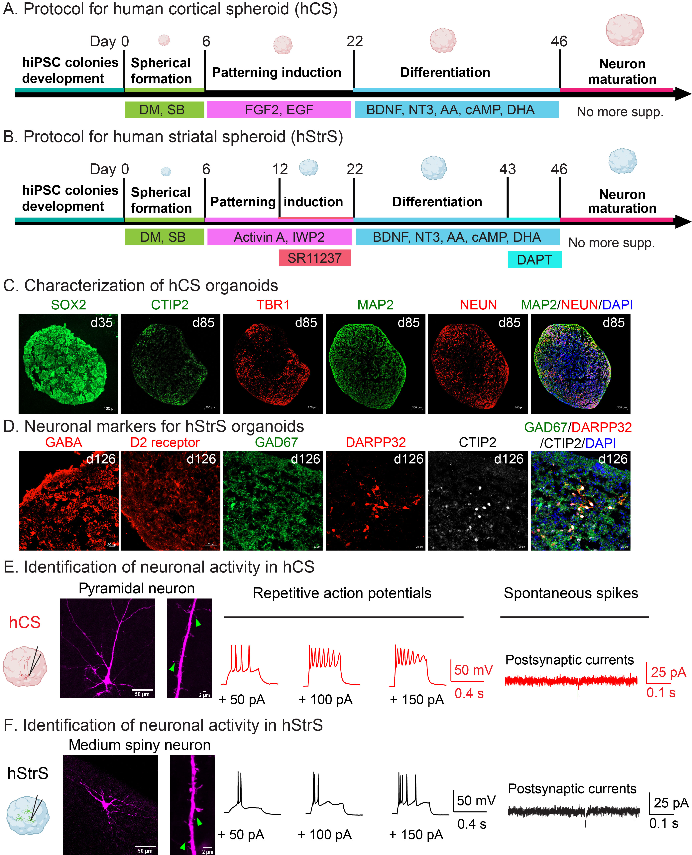

**Fig. 3**. **Generation and characterization of human brain organoids.** **A-B:** Schematic illustrating the protocol for generation of human cortical spheroid (hCS), human striatal spheroid (hStrS). **C-D**: The immunistaining of specific neuronal makers for hCS and hStrS. **E-F**: Illustration of hCS, hStrS and their principal neurons and spines (left); Rrepresentative action potentials (current-clamp, middle) and spontaneous spikes (voltage-clamp, right). (Preliminary data). **Abbreviations:** SOX2, SRY-Box transcription factor 2;CTIP2, COUP-TF-interacting protein 2; TBR1, T-box brain 1; MAP2, microtubule-associated protein 2; NEUN, biomarker for neurons; GABA, γ-aminobutyric acid; GAD67, glutamic acid decarboxylase 67; DARPP32, dopamine- and cAMP-regulated phosphoprotein 32.

2. Increased intrinsic neuronal excitability in hStrS with *SCN2A-C959X* mutation.

To study *SCN2A* deficiency in severe autism, we used **CRISPR/Cas9** to introduce the ***SCN2A-C959X* mutation** (Cysteine 959 to a stop codon) and generated WT (isogenic control), heterozygous (HET), and homozygous (HOM) hiPSCs (**Fig. 4A**) in collaboration with Dr. William C. Skarnes. While clinically observed is HET, we also study HOM in some experiments as it may exhibit a more severe phenotype, convincing what I find from HET. Immunostaining confirmed **NaV1.2 presence** in hStrS, while qPCR and WB data showed reduced ***SCN2A* mRNA** and **protein levels** in ***C959X*** hStrS groups (**Fig. 4B-D**), suggesting the *C959X* mutation triggers **nonsense-mediated decay (NMD)**, degrading mRNA with premature stop codons to prevent faulty protein accumulation, leading to NaV1.2 deficiency. Patch-clamp recordings of medium spiny neurons (MSNs) in hStrS slices showed increased firing rates in HET compared to WT, indicating heightened excitability in *SCN2A*-deficient human striatal neurons (**Fig. 4E-G**), consistent with our previous findings in mouse cortex and striatum with severe *Scn2a* deficiency (75% reduction)33.

3. Shortened axon initial segment (AIS) and reduced synaptic connections in *SCN2A-C959X* mutation hStrS.

Since NaV1.2 localizes to axon initial segments (AIS), and plays a crucial role in initiating action potentials27,28, I investigated axon plasticity mechanisms by assessing AIS length with the ankyrin-G marker, finding it shortened in the mutation group (**Fig. 5A**). As NaV1.2 expression later shifts to the soma and dendrites**29,30**, I also analyzed synaptic connections, observing reduced colocalization of excitatory (Syn1/PSD95) and inhibitory (VGAT/Gephyrin) synaptic puncta in HET and HOM groups (**Fig. 5B-C**). These findings suggest a structural deficit in axon and dendrite associated with NaV1.2 deficiency.

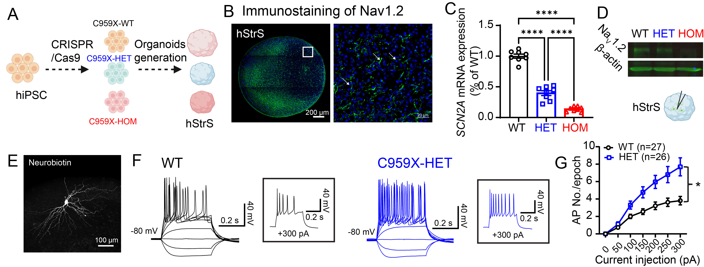**Fig. 4**. **Increased instrinc neuronal excitability in hStrS with *SCN2A-C959X* mutation.** **A**. Schematic illustrating the generation mutation hStrS. **B:** Immunostainings of NaV1.2 on hStrS on day 180. **C, D**: The *SCN2A* mRNA expression and protein reduced in hStrS with *C959X* mutations. ****, p<0.0001, (ANOVA with Bonferroni) **E:** Representative recorded MSN which label by neurobiotin in hStrS. **F-G:** The representative firing and increased action poteintial (AP) firing rates in human striatal MSN carrying *SCN2A-C959X* *HET* mutation *, p<0.05. (2way ANOVA with Bonferroni). Data represent means ± SEM. (**E-F new preliminary data**)

**Rationale**

Research indicates that cortex and striatum are key regions associated with ASD and social behaviors34-38. Disruptions in cortico-striatal circuitry are observed in both experimental ASD models and individuals with ASD6,8,19-22. Our previous work demonstrated that severe NaV1.2 deficiency increases neuronal excitability in the cortex and striatum of adult mice33. Interestingly, my preliminary data show hyperexcitability in NaV1.2-deficient striatal organoids (**Fig. 4**). Here, I *propose* to validate these initial findings of hyperexcitability in hStrS and to investigate similar effects in cortical pyramidal neurons using patch-clamp recordings. Further, I *propose* to assess overall excitability of hCS and hStrS organoids via microelectrode array (MEA) recording. Mechanistically, I *propose* to validate the preliminary finding of shortened AIS length in *SCN2A*-deficient hStrS (**Fig. 5A**) and examine its impact on cortical pyramidal neurons. Preliminary data also suggest reduced excitatory and inhibitory synaptic connections in *SCN2A*-deficient hStrS (**Fig. 5B-C**); therefore, I *propose* to confirm these synaptic deficits in hStrS and assess them in cortical neurons to explore potential synaptic disruptions in both hCS and hStrS models. This aim differs from Dr. Yang’s lab, which focuses on *Scn2a* deficiency in mouse models, as I am utilizing a human context model by specifically studying the human *C959X* mutation to represent *SCN2A* deficiency.

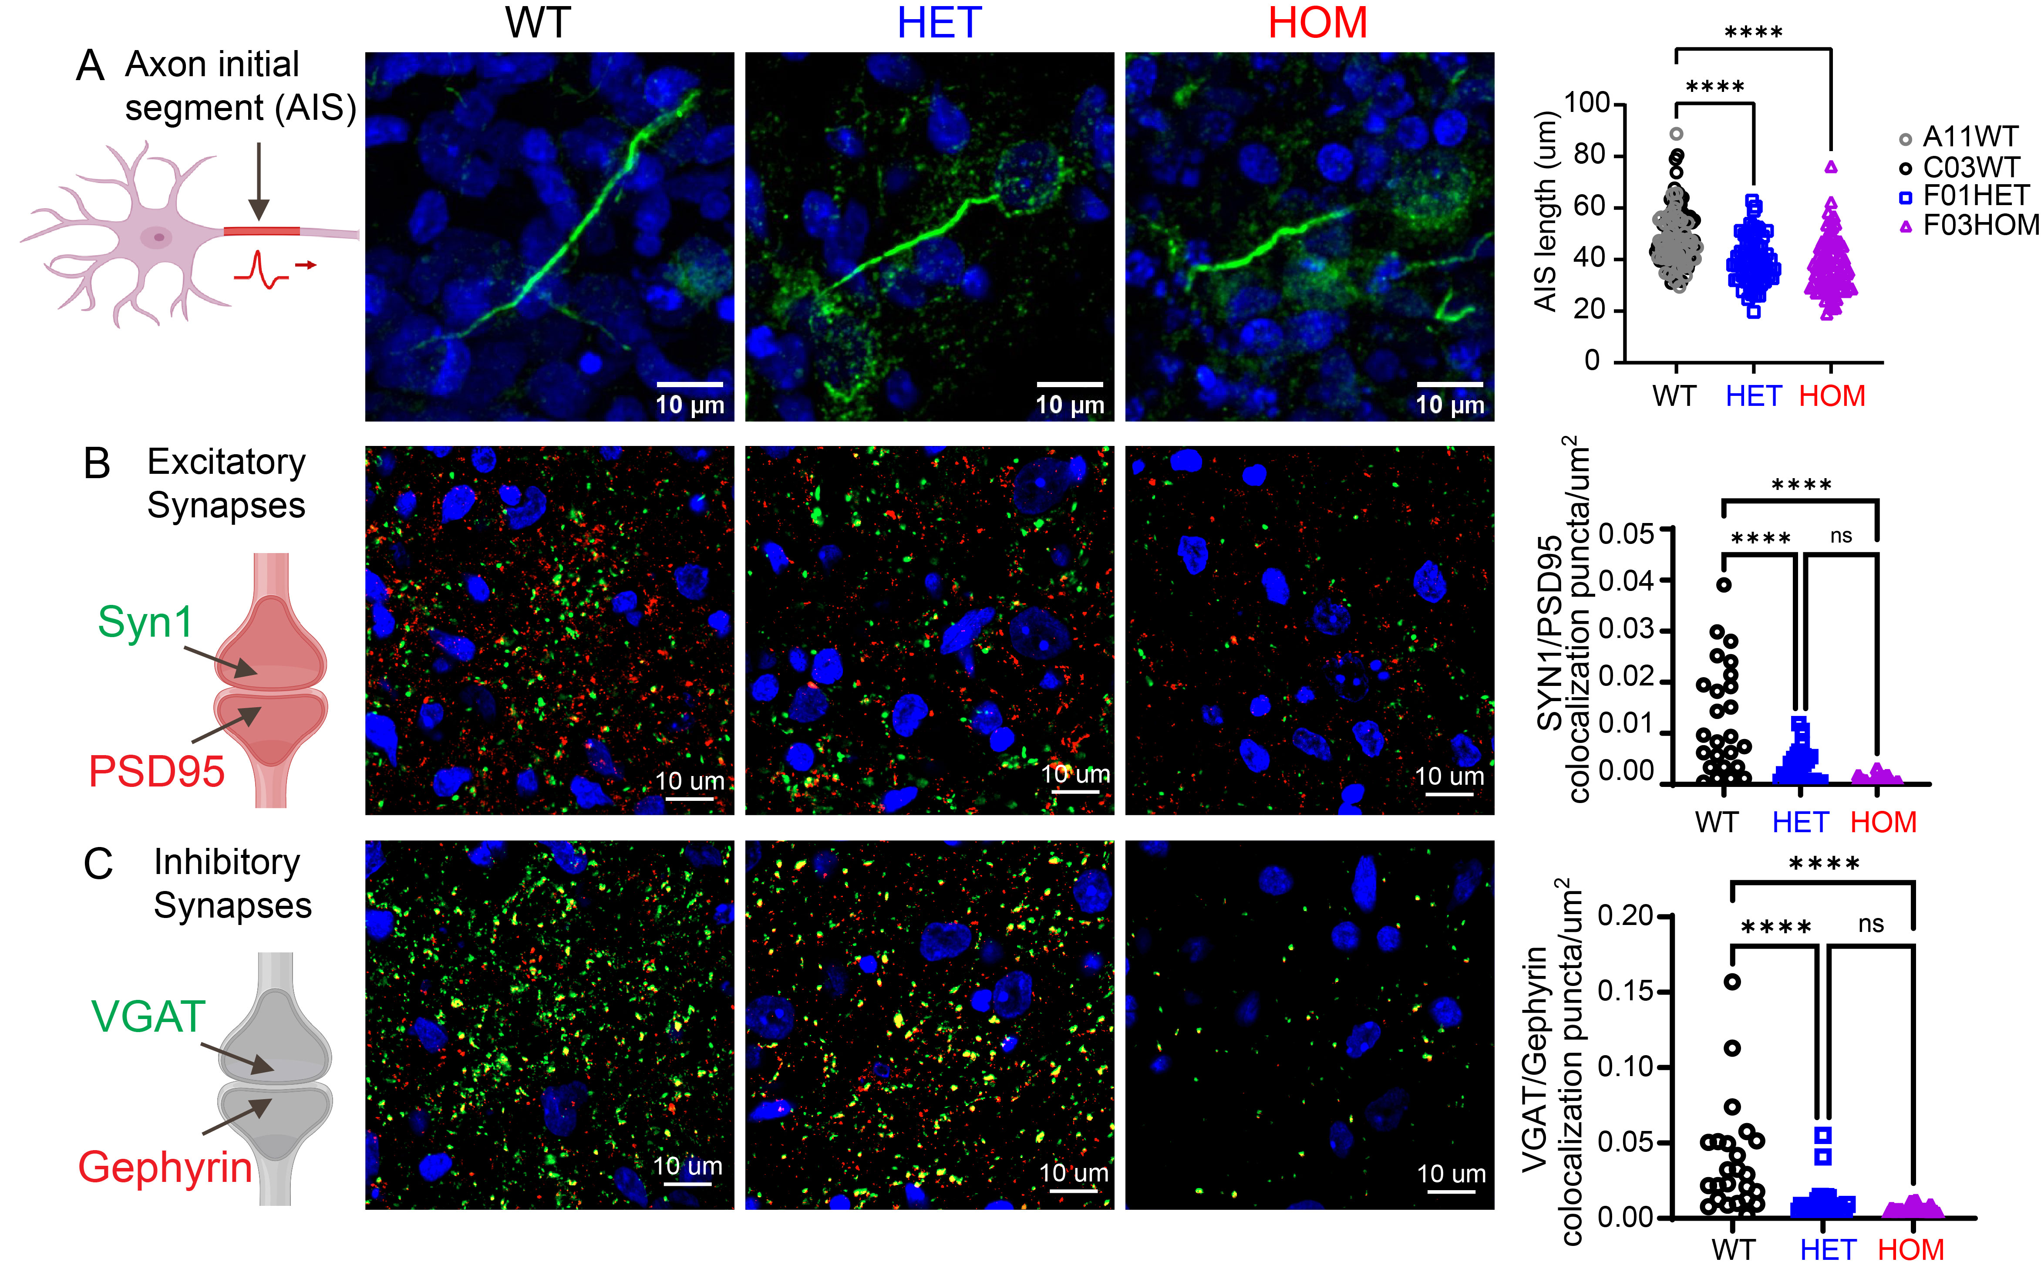 **Fig. 5**. **Reduce axon initial segment (AIS) and altered synaptic connection of excitatory and inhibitory synapses in *SCN2A-C959X* mutation hStrS.** **A:** The representative axon initial segment (AIS) by ankyrinG immunostaining (green) and reduced AIS length in *SCN2A* dificienct hStrS. **B**: The representative image and reduction of colocalized excitory synaptic puncta (Syn1, pre-synaptic markers, green; PSD95, post-synaptic markers, red). **C**: Representative images and reduction of colocalized inhibitory synaptic puncta (VGAT, pre-synaptic markers; Gephyrin, post-synaptic markers, red) in HET and HOM group. ****, p<0.0001. (ANOVA with Bonferroni). Data represent means ± SEM. (**New preliminary data**)

**Experimental design**

**Exp. 1.** Evaluate impact of *SCN2A* deficiency on neuronal activity in hCS and hStrS by patch-clamp recording.

To assess *SCN2A* deficient impact on neuronal excitability, I will use patch-clamp to characterize electrophysiological phenotypes. 4-month-old WT and *C959X* mutation hCS and hStrS will be sliced (200 μm thick) using a vibratome (Leica VT1200 S). Pyramidal neurons in hCS and medium spiny neurons (MSN) in hStrS will be recorded by a standard internal solution for whole-cell current-clamp recording33. Parameters including resting membrane potential (RMP), sag ratio, input resistance, and firing number during 400-ms current pulses from -200 to +400 pA will be measured. Recorded neurons will be labeled with a neurobiotin tracer added into the internal solution for post-recording visualization.

**Exp. 2.** Determine the overall neural activity of hCS and hStrS with *SCN2A* deficiency by MEA recording.

To assess the impact of *SCN2A* deficiency on overall neural activity in organoids, I will conduct MEA recording (Axion system) on hCS. 4-month-old WT and *SCN2A-C959X* hCS will be seeded on PLO-laminin-coated 48-well MEA plates, following our established protocol39. Organoids will be maintained in BrainPhys medium with additives for 2 weeks, then recorded for 10 minutes after stabilized for 5 minutes in the Maestro system at 37°C and 5% CO2. Voltage spikes, active electrodes, firing rate, synchrony index, and bursting frequency will be analyzed using the Neural Metrics Tool (version 2.4, Axion Biosystems).

**Exp. 3.** Examine cellular and subcellular structural alteration in hCS, and hStrS by immunostaining.

To examine structural alternation from *SCN2A* deficiency, 20–40 μm organoid sections (Leica CM1950) from 3–4 month-old hCS and hStrS are collected, permeabilized, blocked, incubated with primary and secondary antibodies, and imaged on a Zeiss LSM 900 confocal microscope with analysis in Fiji/ImageJ. I will quantify **1)** AIS length by marker ankyrin-G; **2)** excitatory synapses (Syn1, PSD95) and inhibitory synapses (VGAT, Gephyrin).

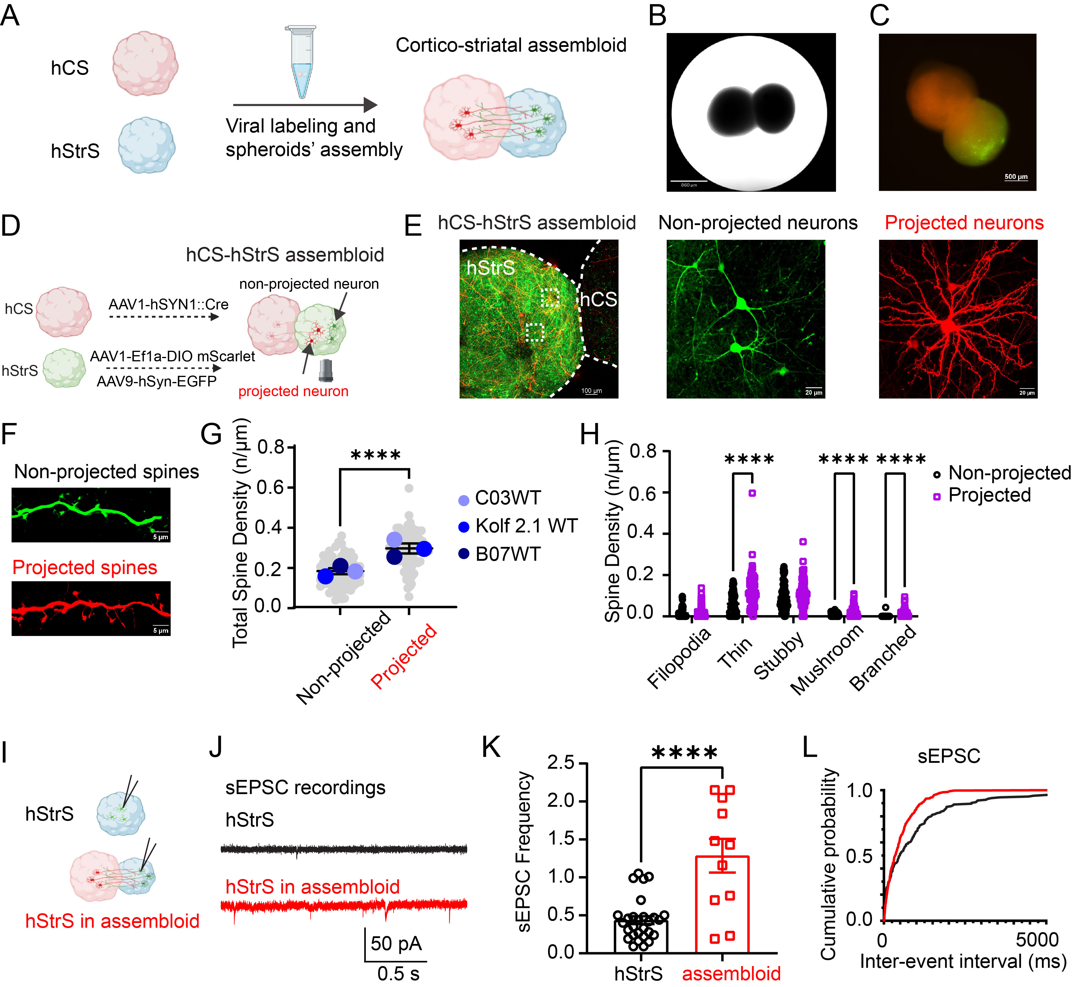**Fig. 6. Generation of human assembloids to study cortical-striatal (CS) connectivity.** **A**. Schematic showing the generation of CS assembloids. **B, C**. Images of CS assembloids under bright-field (**B**) and fluorescence (**C**) microscopy. **D**. Schematic of labeling strategy for projected and non-projected neurons in CS assembloids. Projected neurons are labeled with mScarlet (red), and non-projected neurons with EGFP (green) in hStrS. **E**. Projected (red) and non-projected (green) neurons and their spines (**F**) in CS assembloids. **G, H**. Statistical analysis of increased total spine density and spine density across spine types. **I-L**. Schematic, representative recording, and summary of increased sEPSC in assembloids. ****, p<0.0001. Data shown as means ± SEM. (**I-L, new preliminary data**)

**Anticipated results: 1)** In line with previous hStrS data, I anticipate increased intrinsic excitability of principal neurons in hCS, including depolarized resting membrane potential (RMP), higher input resistance, and reduced amplitude. **2)** Increased overall neural firing rate, synchrony index, and bursting frequency are anticipated in hCS and hSrS with *SCN2A* deficiency. **3)** Expect shorter AIS length in hCS, consistent with my hStrS findings and AIS length's correlation with sodium conductance40-42. **4)** Anticipate reduced colocalization of excitatory (Syn1/PSD95) and inhibitory (VGAT/Gephyrin) synaptic puncta in mutation groups in hCS and hStrS.

**Potential pitfalls and alternative approaches**

Based on my preliminary data, I do not expect major technical issues for experiments in Aim 1. **1)** In patch-clamp recordings, if there are significant changes in RMP, parameters will be also recorded at a holding potential of -70 mV for hCS and -80 mV for hStrS. **2)** For MEA recording, if spontaneous firing signals are too weak, I will apply external stimuli to enhance neural firing and detect genotype-specific differences. If the attachment of the organoid on the plate is insufficient, I plan to dissociate 3D cultures to 2D for better electrode attachment using PLO/laminin coating. **3)**  Given that various neuronal markers are expressed at different stages during the growth of organoids43, I plan to meticulously choose the appropriate time points for immunostaining.

**Aim 2 (K99/R00 phase):** **Elucidate circuit phenotypes and molecular mechanisms in *SCN2A*-deficient human brain assembloids.**

**Preliminary data**

1. Successful generation of human assembloids to study cortico-striatal (CS) connectivity.

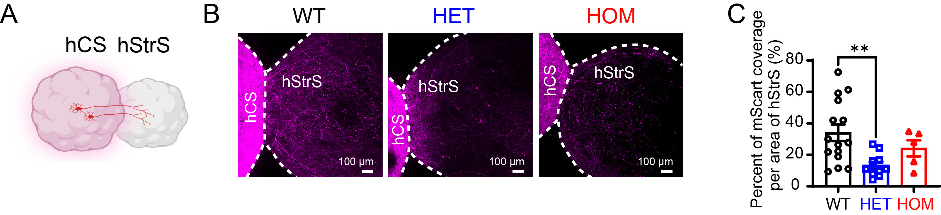**Fig. 7**. **Impaired axon projection in human brain assembloids carrying *SCN2A-C959X* mutation.** **A**: Schematic showing hCS to hStrS projection. **B**. Representative imaging of cortical-striatal axon projection. **C**: Reduced cortical-striatal axon projections in HET assembloids d42 after fusion. **, p<0.01. (ANOVA with Bonferroni). Data represent means ± SEM. (Preliminary data)

To model cortico-striatal circuitry involved in autism23-26, hCS and hStrS were seeded horizontally in 1.5 mL tubes on day 60 to form a super CS assembloid within a week, following Miura’s protocol31 (**Fig. 6A-C**). To study the projected neurons, I labeled hCS with AAV1-hSyn1-Cre and hStrS with AAV1-Ef1a-DIO-mScarlet and AAV9-hSyn-EGFP, creating CS assembloids (**Fig. 6D-E**). In hStrS, Cre recombinase induces DIO-mScarlet expression, marking cortical-projection neurons in red, while EGFP non-selectively labeled striatal neurons in green. Quantifying spine densities, I found that projected neurons in hStrS had significantly higher densities, including thin, stubby, and mushroom spines, than non-projected neurons (**Fig. 6F-H**). Functionally, I recorded spontaneous excitatory postsynaptic currents (sEPSC) in organoid and assembloid slices, observing increased sEPSC in assembloids (**Fig. 6I-L**). These suggest that glutamate release by cortical projection may promote spine formation and maturation in striatal neurons at structural and functional levels.

2. Impaired axon projection in CS assembloids carrying *SCN2A-C959X* mutation.

Given NaV1.2's primary location on axons and its crucial role in axonal function, I explored the impact of *SCN2A* deficiency on axon projections. At day 60, hCS organoids were labeled with AAV1-hSyn-mScarlet, and fused with hStrS at day 65 to form CS assembloids for cortical axon projection analysis. Data showed notably reduced cortico-striatal axon projections in HET assembloids (**Fig. 7**), indicating impaired axon projection.

3. Reduction in synapse and axon-related pathways in CS assembloids carrying *SCN2A-C959X* mutation.

To uncover the molecular mechanisms behind the observed cellular and subcellular deficits, I examined gene expression profiles and pathways using RNA sequencing. At the single-gene level, I identified 2663 up- and 2851 down-regulated genes in HET (**Fig. 8A**). At the pathway level by KEGG, the most significantly altered pathway in HET assembloids is axon guidance, with 4 of the top 10 pathways linked to synaptic function (**Fig. 8B**). Ingenuity pathway analysis (IPA) further reveals downregulation in dendritic growth and synaptogenesis synapse signaling pathways (**Fig. 8C**). Together, these RNA-seq findings and the observed axon projection impairments suggest that disrupted cortico-striatal circuitry may be a major phenotype and mechanism in *SCN2A* deficiency autism.

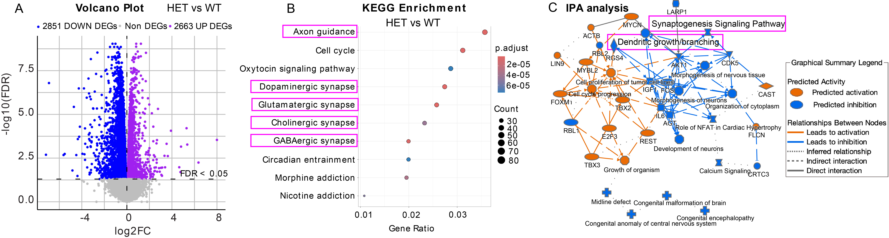 **Fig. 8**. **RNA sequencing of** **human CS assembloids showed reduction in synapse and axon related pathways in *SCN2A-C959X* mutation.** **A:** Volcano plot of gene expression. Blue points represent statistically significantly downregulated genes, while purple points represent statistically significantly upregulated genes in HET samples compared to WT samples. Grey points represent genes that are not significantly different. **B**, List of top 10 pathways (Kyoto Encyclopedia of Genes and Genomes, KEGG) altered between samples from HET and WT CS assembloids (Fisher’s test). **C**. The network pathway change in IPA analysis. Blue color indicate significantly downregulated pathway, while organe color indicate significantly upregulated pathway in HET vs. WT samples. Dendritic growth and synaptogenesis signaling pathway are down regulation. (n=7 HET and 7 WT assembloid). (**New preliminary data**)

**Rationale**

Studies indicate disruptions in cortico-striatal circuitry in both ASD models and affected individuals6,8,19-22. To model these circuits*,* I developed the CS assembloids to explore circuit phenotypes and molecular mechanisms. Given the pivotal role of NaV1.2 in axons and dendrites, and preliminary data showing impaired axon projections (**Fig. 7**) and reduced dendritic growth pathway (**Fig. 8**), I *hypothesize* that *SCN2A* deficiency disrupts cortico-striatal circuit by impairing axonal projections and dendritic function and reduce neurotransmitter release. To test this, I propose to **1)** validate impaired axonal projections in CS assembliods; **2)** record spontaneous excitatory postsynaptic currents (sEPSCs) and quantify spine density in projected MSN in CS assembliods to assess synaptic function; **3)** detect neurotransmitter release; **4)** elucidate the molecular and cellular mechanisms of *SCN2A* deficiency affects brain circuits at single-cell level by single-cell sequencing (scRNA-seq). Here, I use an in vitro CS assembloid model, which differs from Dr. Yang’s lab approach.

# Experimental design

**Exp. 4.** Live imaging of axon projection in CS assembloids carrying *SCN2A-C959X* mutation.

To assess the effect of *SCN2A* deficiency on axon projection, hCS organoids will be labeled with AAV1-hSyn-mScarlet, and fused with hStrS at day 65 to form CS assembloids for studying projecting axons from the cortex. Imaging will occur on **days** **20, 30, and 42** **post-fusions**. Assembloids will be moved to a confocal plate and subjected to z-stack imaging with a 10X lens, reaching depths of up to 500 μm using a confocal microscope at 37°C and 5% CO2. Cortical projections inside hStrS will be analyzed using Fiji/ImageJ.

**Exp. 5.** Measuring sEPSC and spine density of projected striatal neurons in CS assembloids.

To assess the impact of the *SCN2A-C959X* mutation on synaptic function in projected neurons within hStrS of assembloids, I will label hCS with AAV1-hSyn1-Cre and hStrS with AAV1-Ef1a-DIO-mScarlet and AAV9-hSyn-EGFP at day 60 and generate CS assembloids at day 65. In hStrS, Cre recombinase will induce DIO-mScarlet expression, marking cortical-projection neurons in red. Confocal z-stack imaging of dendritic spines on projected striatal neurons (red) will be conducted 30 days post-fusion using a 20x lens with a 6x zoom-in. The sEPSCs of the projected striatal neurons (red) will be recorded using patch-clamp, and morphology and synaptic features will be verified post-recording through biocytin staining. Spine types and densities will be analyzed with Neurolucida software.

**Exp. 6.** Examining neurotransmitter levels in CS assembloids with *SCN2A* deficiency.

To investigate the effect of *SCN2A-C959X* mutation on neurotransmitter levels, WT and *C959X* mutation CS assembloids will be generated and collected at 5 months, then homogenized for intracellular neurotransmitter analysis. Also, monthly medium samples will be collected and stored at -80℃ to monitor neurotransmitter release. After I collect samples, my co-mentor Dr. Cannon44 lab will help me to prepare samples and conduct ultra-performance liquid chromatography with electrochemical detection (UPLC-ECD). Dr. Cannon will also assist in interpreting and analyzing the signals. While we expect specific neurotransmitter modulations of glutamate, GABA, we will broadly measure monoamine and amino acid neurotransmitters so we can report whether effects are selective or across systems. When the samples are collected, the workflow includes 1 weeks for preparation, 1 weeks for sample running, and 2 weeks for analysis, taking about 1 months in total. I will examine a minimum of 8 assembloids per group. Mastering neurotransmitter quantification is essential for my goal of understanding how brain neurotransmitters influence neuronal behavior in organoid models of neurological disorders.

**Exp. 7.** Elucidating molecular mechanisms of *SCN2A-C959X* assembloids by scRNA sequencing.

To unravel the molecular alterations and pathways in *SCN2A*-deficient CS assembloids at the single-cell level, hCS will be labeled with AAV1-hSyn-mScarlet and hStrS with AAV9-hSyn-EGFP, then fused at day 65. After two months, the assembloids will be separated into hCS and hStrS components for scRNA-seq. I plan to use PIPseq™ V T20 3ʹ single-cell RNA kit (Fluent BioSciences) to isolate single-cell RNA and capture 3ʹ mRNA fragments for sequencing. The cell will be lysed, RNA will be reversely transcribed into cDNA, and unique molecular identifiers will be added for precise transcript quantification before library preparation and sequencing. The experiment and subsequent bioinformatics analysis will be conducted under the supervision of my collaborator Dr. Yunlong Liu45, a bioinformatics expert. When the samples are ready, the workflow includes 2 weeks for preparation, 2 weeks for sample sequence, and 4 weeks for analysis, taking about 2 months in total. Proficiency in scRNA-seq is essential for my career focused on investigating cell interactions and gene expression alterations within genetic variants.

**Anticipated results:** Based on my preliminary data,human CS assembloids with *SCN2A* deficiency are expected to show **1)** reduced axon projections on days 20, 30, and 42 post-fusion; **2)** reduced sEPSC and spine density in projected neurons in hStrS, including thin, stubby, and mushroom spines; **3)** decreased neurotransmitter (glutamate, GABA) release and intracellular neurotransmitter in CS assembloids; **4)** downregulation of genes involved in axon and synapse in the cortico-striatal projected neuron.

Potential pitfalls and alternative approaches

With my prior experience and preliminary data, I anticipate no major technical issues for Exp. 4 and Exp. 5. **1)** In Exp. 6, the manufacturer reports a sensitivity of sub-femtomole on the detector. If sensitivity issues arise, I can increase the sample size by enhancing the total assembloid mass. Should spontaneous neurotransmitter release prove insufficient, I will utilize a stimulator to boost release. Additionally, for low levels of intracellular neurotransmitters, I will concentrate on isolating hStrS to specifically evaluate these neurotransmitters. **2)** In Exp. 7, if dissecting assembloids into distinct regions is challenging due to entangled projections and unclear boundaries, I will perform scRNA-seq on the entire assembloid. Single nuclei analysis will be considered as an alternative if live single cells are not sufficient in the preliminary experiment.

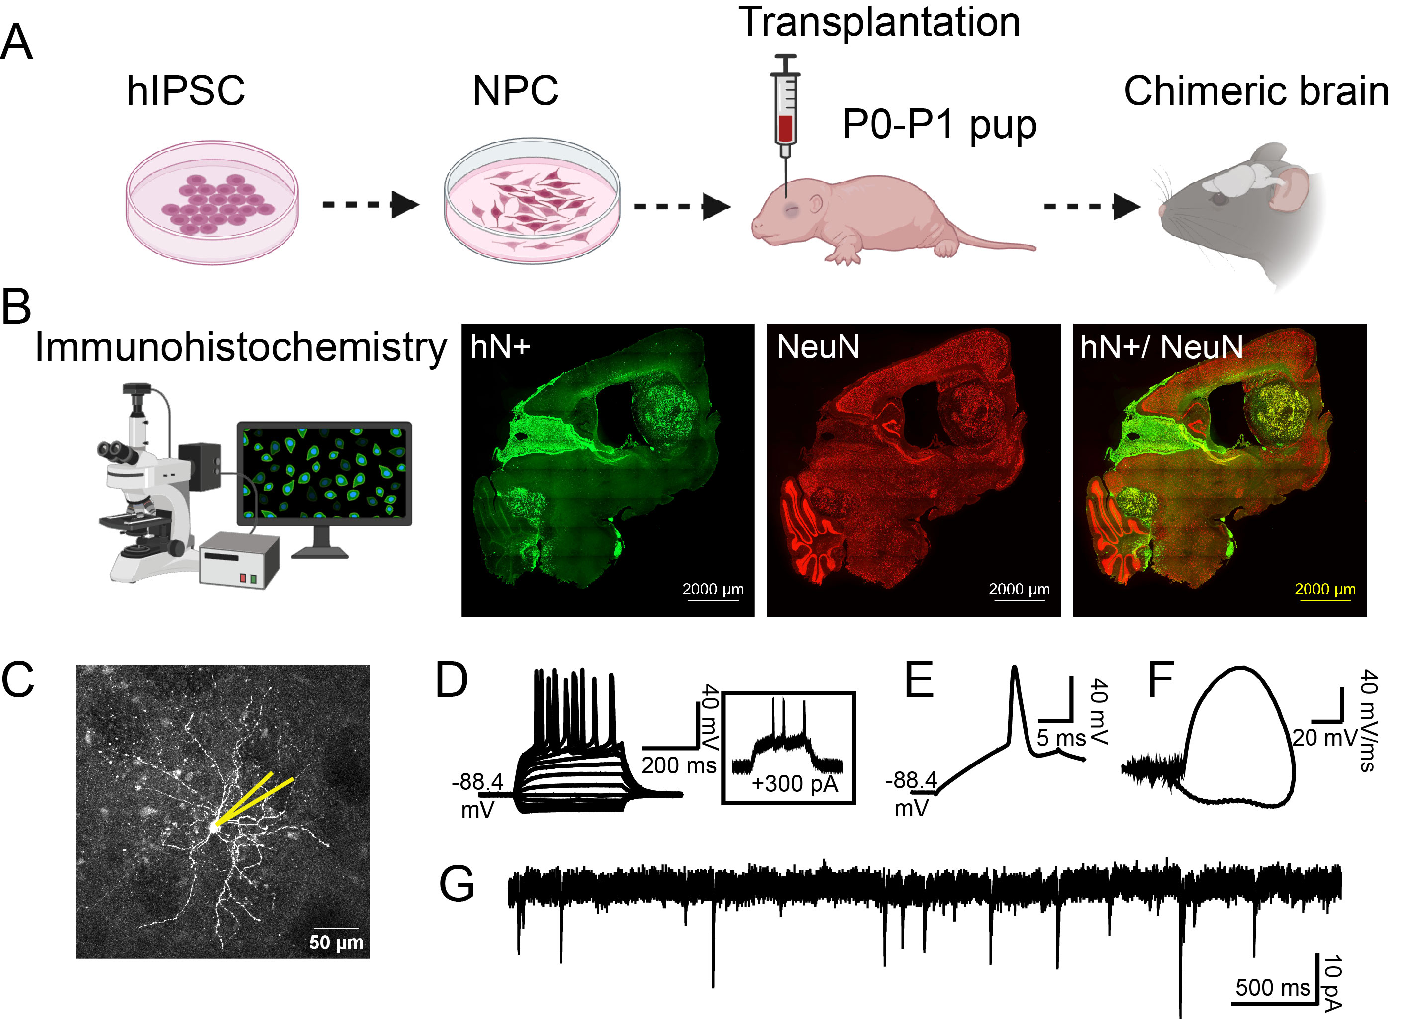 **Fig. 9**. **Successful generation of human-mouse chimeric brains**. **A**: Schematic showing the transplantation of human neural progenitor cells (NPCs) into P0-P1 *Rag1−/−* mouse brains, resulting in detectable chimeric brains. **B**: Immunohistochemistry image of chimeric brains at 6 months post-transplantation, displaying human nuclei positive (hN+) cells in green and NeuN positive cells in red. **C**: Schematic illustrating patches on human neurons in the chimeric mouse brain. **D**: Raw recording of human neurons at resting membrane potential (RMP), with traces produced by 400-ms hyperpolarizing and depolarizing steps in 50-pA increments. **E**: A typical action potential of human neurons, with an associated phase plane plot shown in **F**. **G**: Raw recording of miniature excitatory postsynaptic currents (mEPSCs) in human neurons (**C-G new preliminary data**).

**Aim 3 (R00 phase):** **Assess** **circuit abnormalities and autistic-like behaviors in human-mouse chimeric brains with *SCN2A* deficiency.**

**Preliminary data**

1. Successful generation of chimeric brains.

To build human-mouse chimeric brains, we dissociated and transplanted human neural progenitor cells (NPC) into neonatal *Rag1−/−* mice46, which lack mature T and B cells, creating an immunodeficient environment conducive to human cell integration guided by Dr. Ranjie Xu, an expert with a decade of experience in this model47,48 (**Fig. 9 A**). 4-6 months post-transplantation, human cells were successfully identified in key brain regions including cortex and striatum (**Fig. 9 B**). Functionally, we examined neuronal excitabilities, observing mature action potentials and spontaneous postsynaptic currents (**Fig. 9 C-G**). Data collectively indicate that human neurons are structurally and functionally well-developed at the neuronal and circuit levels in the mouse brain. This model offers a unique opportunity for analyzing human-derived neuron-involved circuit reconstruction in a physiological environment.

2. Mice implanted with HET *SCN2A-L1342P* NPCs tended towards increased self-grooming behavior.

To investigate the behavioral effects of the *SCN2A* mutation, we recorded the activities of chimeric mice over three days using the Laboratory Animal Behavior Observation Registration and Analysis System (LABORAS)49. This system allowed us to assess locomotion, grooming, and social interactions to better understand how the *SCN2A* mutation impacts behavior. Preliminary data indicated a tendency for increased self-grooming behavior in the *SCN2A-L1342P* mice, while locomotion and speed remained normal. Since self-grooming is often regarded as a repetitive behavior characteristic of autism50, these findings suggest that a proportion of human neurons with *SCN2A-HET* mutation can induce autistic-like behaviors in chimeric mice.

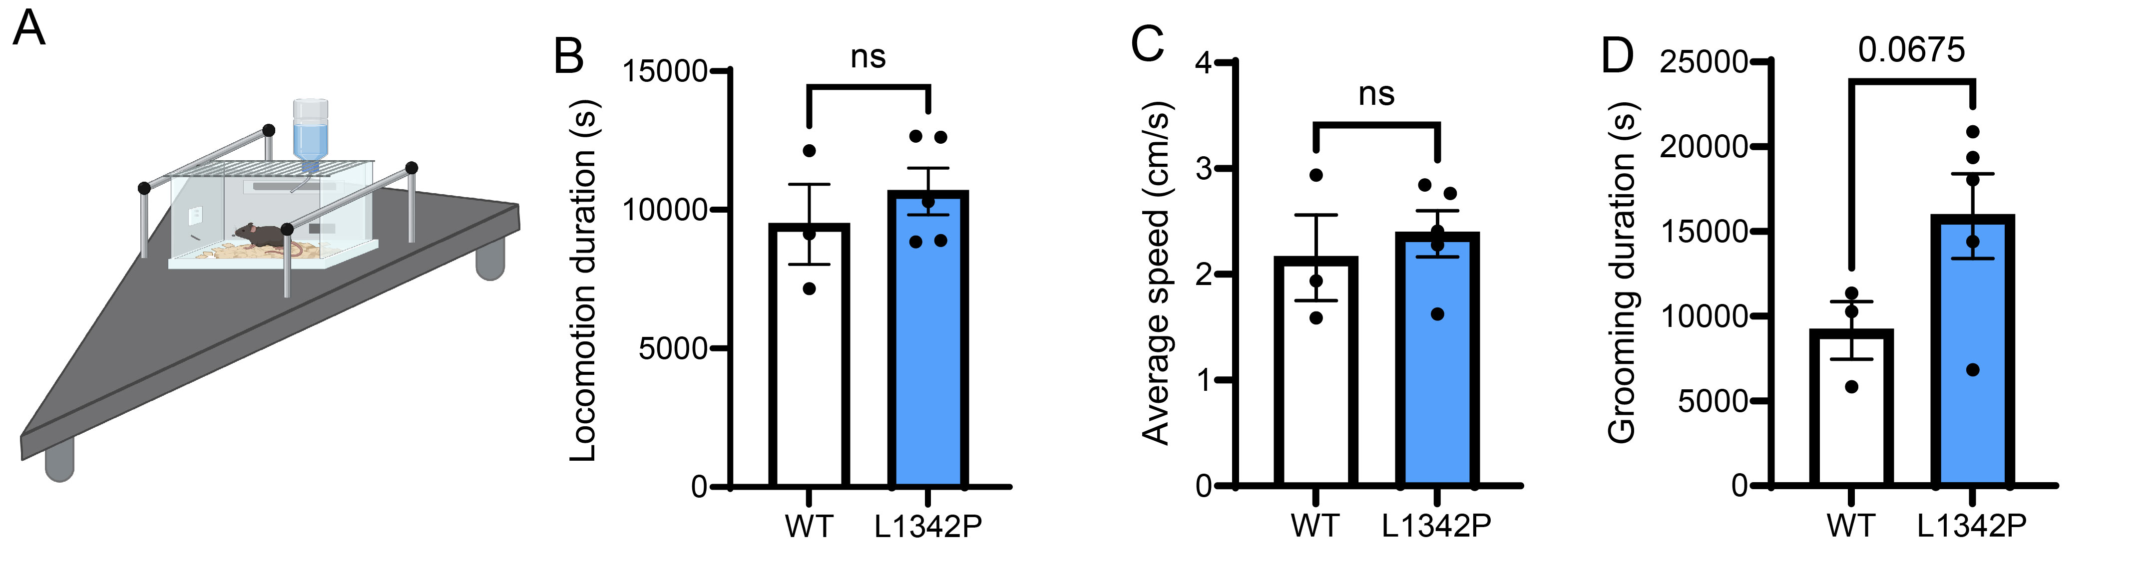 **Fig. 10. Mice implanted with *SCN2A-L1342P* NPCs exhibited a tendency for increased self-grooming behavior while maintaining normal locomotion. A:** Schematic of behavior recording in chimeric mice using LABORAS over 3 days. **B**: No significant changes in locomotion observed. **C**: Average speed remained unchanged. **D**: Increased self-grooming behavior was noted in the *L1342P* group (n=3 WT, n=5 *L1342P* mutant, T-test) (**New preliminary data**).

3. *Scn2a*-deficient mice show increased neuronal activity and social impairments.

In my prior study, we developed a novel *Scn2a*-deficient mouse model using a gene-trap strategy, allowing homozygous (*Scn2agt/gt*) mice to survive with residual NaV1.2 expression (~25% of WT level)51, and exhibit severe social deficits (**Fig. 11F**). I used these mice to study neuronal activity related to autism-like behaviors. I injected AAV1-hSyn-GCamP6s and implanted a Prism lens (Inscopix) into the striatum of adult mice. 1 month later, I recorded neuronal activity by calcium imaging and simultaneously assessed sociability by performing a social preference test in a linear three-chamber (**Fig. 11A-C**). Data showed increased neuronal activity and reduced social time for the *Scn2a*-deficient mice (**Fig. 11D-F**), highlighting their social deficits and my ability to conduct this critical experiment.

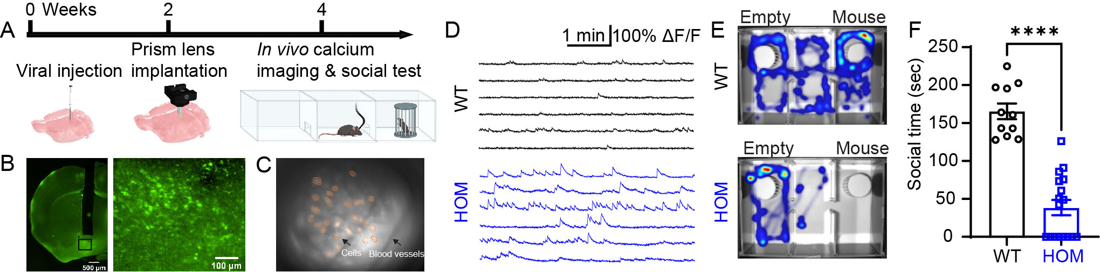**Fig. 11. Social deficits in *Scn2a*-deficient (*Scn2agt/gt*) mice. A:** Diagram showing AAV1-GCamP6s injection, Prism lens implantation, and live calcium imaging during social interaction tests. **B, C**: Sample images of GCamP6s expression in the mouse striatum. **D**: Typical calcium signal traces from WT and HOM neurons. **E, F**: Heat maps and summary indicating decreased social interaction in HOM mice. (n=12-14 mice per group). ***, p<0.001 (unpaired *t-*test). Data are means ± SEM. (Preliminary data)

**Rationale**

In **adult *Scn2a+/-* mice**, there are **no major social deficits or impairments** in intrinsic and network excitability10-14. However, in my **human brain organoid and assembloid models**, heterozygous ***SCN2A-C959X* mutation** induces **hyperexcitability** (**Fig. 4**) and **impaired circuits** (**Fig. 7**). I *hypothesize* that even a **small proportion of dysfunctional human cells** can significantly impair human-human and human-mouse circuits52, contributing to behavioral impairments53,54. To test this, our preliminary data from chimeric mice with *SCN2A*-mutant human neurons show a trend of increased grooming behavior (**Fig. 10**), supporting the feasibility of using chimeric mice to study behavior. Thus, to address a **notable gap in studying *C959X* mutation autistic-like behaviors *in vivo*** with human neuron models. I will **transplant *SCN2A*-mutant human neurons into mouse brains**, creating a **human-mouse chimeric brain model** for a more comprehensive study of impaired CS circuit, autistic behavior and how the human neurons control mouse behavior. Mastering the chimeric brain model guided by co-mentor Dr. Ranjie Xu is critical to my goals of deciphering human brain disorders within a chimeric model, bridging human neuronal activity and mouse behavior. The chimeric mouse model I choose here is differ from Yang’s lab.

# Experimental design

**Exp. 8.** Assessing circuitry abnormalities in chimeric brain carrying *SCN2A-C959X* mutation.

Wild-type and *C959X* mutant NPCs will be transduced with retrograde CAV-2-CAG-mCitrine and transplanted into the striatum of P0-P1 *Rag1−/−* immunodeficient mice, a region associated with autism pathophysiology6,24. 6 months later, chimeric brains will be cleared using iDISCO+ or SHIELD techniques under the guidance of co-mentor Dr. Kimbrough, an expert in whole-brain clearing and imaging55. Light-sheet microscopy will then be used to scan the cleared brains for high-resolution visualization of reconstructed circuits. The retrograde expression of CAV-2 will enable circuit analysis by highlighting mCitrine-labeled neuronal somata and axons. and plan time for clear, image and analysis will be 2 months. Mastering these tissue-clearing techniques is crucial for my future research on neural circuit mapping using whole-brain labeling and imaging, overcoming previous limitations in visualizing single-cell changes throughout the entire brain.

**Exp. 9.** Assessing behavior abnormalities in chimeric brain carrying *SCN2A-C959X* mutation.

To investigate cortico-striatal circuit-related behaviors, WT and *C959X* mutant NPCs will be injected into the cortex and striatum of P0-P1 *Rag1−/−* mice. Behavioral assessments at 2, 4, and 6 months will use the LABORAS system to monitor autism-like behaviors, including repetitive behaviors (self-grooming, marble burying), locomotion, and anxiety-like activities, as shown in my previous work51, and social interaction via the three-chamber social preference test. Mice will be acclimated and placed individually in LABORAS-compatible cages for continuous 24-hour recording, automatically classifying behaviors such as grooming, locomotion, and rearing. For the three-chamber test, mice will be habituated for 10 minutes, followed by the introduction of a novel WT mouse in one chamber, with the other chamber remaining empty. Behavior will be recorded for an additional 10 minutes, measuring time spent in each chamber, with social sniff time used for more accurate assessment of direct social interaction. I am supported by Dr. Koss, director of the animal facility, for mouse behavior experiment (see support letter).

**Exp. 10.** Assessing human neuronal activity in *SCN2A*-deficient chimeric mice during social behavior.

Human WT and C959X mutant NPCs will be transduced with AAV1-Syn-jGCaMP8m and transplanted into the striatum of mice. After 2 months, an Inscopix Prism lens will be implanted in the chimeric brain (coordinates: AP +1.35 mm; ML +1.05 mm; depth 4.00 mm). Following a month of recovery, mice will undergo one week of habituation in the three-chamber apparatus. Behavioral video will be recorded with EthoVision XT (Noldus), while simultaneous *in vivo* calcium imaging with the Inscopix nVue system will monitor human neuronal activity—10 minutes baseline and 10 minutes of social interaction with a novel stimulus mouse. Calcium data will be processed using Inscopix Data Processing Software (IDPS). I will collaborate with experienced advisors Dr. Hao Li with analysis in correlating calcium activity with social behavior according the references56,57. (See support letter)

### *Table 1. Anticipated Timeline for Proposed Research*

|  |  |  |  |  |  |
| --- | --- | --- | --- | --- | --- |
|  | K99 year | | R00 year | | |
| Exp. | 1st | 2nd | 3rd | 4th | 5th |
| 1 Neuronal activity in organoids |  |  |  |  |  |
| 2 Neural network activity in organoids |  |  |  |  |  |
| 3 Structure change in organoids |  |  |  |  |  |
| 4 Axon projection in assembloid |  |  |  |  |  |
| 5 Synaptic functions in assembloid |  |  |  |  |  |
| 6 Neurotransmitter release |  |  |  |  |  |
| 7 Mechanism by scRNA-seq |  |  |  |  |  |
| 8 Circuit in chimeric brain |  |  |  |  |  |
| 9 Autism-like behavior |  |  |  |  |  |
| 10 Neuronal activities with behavior |  |  |  |  |  |

**Anticipated results:** I expect to acquire outcomes in *SCN2A*-deficient chimeric mice: **1)** light-sheet microscopy of cleared brains will reveal disrupted/reduced cortico-striatal circuit. **2)** increased repetitive behaviors, altered locomotion, heightened anxiety-like behaviors, and reduced social interaction increased repetitive behaviors, **3)** Increased baseline human neuronal activity, disrupted activity of “social” neurons, and reduced social time.

# Potential pitfalls and alternative approaches

**1)** To enhance behavioral deficits, I will increase NPC transplants or injection sites and extend the post-implantation period for improved cell integration. **2)** In Exp.10, I may also adjust the behavioral assay to target other autism-related behaviors linked to cortico-striatal circuitry, such as social reward. **3)** If viral transduction is low, the hSyn promoter will be replaced with CAG for stronger GCaMP8m expression. **4)** ScRNAseq will be considered to assess circuit abnormalities at the cellular level.

# 4. Scientific Rigor and Reproducibility

Given that there are numerous experiments per aim and several outcomes per experiment, we consider a 0.01 significance level for each of the comparisons as this balanced the exploratory nature of the study with some added control for false positives. Because most comparisons will involve a two-sample t test, we determined the sample size necessary to detect a Cohen’s d of 1.0 with 80% power. This sample size of 25 per group was used in all experiments. **Organoid Culture**: Experiments will include a minimum of three hiPS cell lines over two differentiation processes, incorporating at least two to three organoids or assembloids, to account for variability in neuronal differentiation58,59. **Mouse Studies**: Mice of both sexes, aged 0-8 months, will be utilized in Aim 3. Should no statistical significant differences between sexes appear, the results will be pooled. **Statistical Analysis**: Results will be presented using means and standard errors. Most outcomes will be analyzed by the two-sample t-test. The t test is quite robust given the proposed sample size but transformations, such as the log, will be considered if there is severe skewness. Count data, such as the neuron firing rates, will either be analyzed using Poisson or negative binomial regression. Generalized estimating equations (GEE) will be used to account for the repeated measurements. , or by ANOVA (≥3 groups) with Tukey’s post hoc test (all groups compared), or Dunnett’s post hoc (vs. control only). Data failing the D'Agostino &Pearson normality test will be analyzed by nonparametric tests: Mann-Whitney U test (two groups) or Kruskal-Wallis test with a Dunn’s post hoc test (≥3 groups). Comparison of slopes will be assessed by appropriate regression (linear or nonlinear) analysis. For all tests, p<0.05 will be deemed significant.

# 5. Research Timeline (shown in Table 1)

# 6. Future Directions (independence from Yang’s lab): As an independent scientist, I aim to:

# 1) Investigating the pathological development of human cortico-striatal circuits in chimeric mouse brains using advanced brain-clearing techniques. 2) After comparing RNA-seq data from assembloids and mouse models, I will identify both shared (convergent) and unique (divergent) gene and pathway alterations. I plan to further explore these changes. Convergent alterations may highlight common therapeutic targets, while divergent changes could explain why *SCN2A-HET* mutations are sufficient to cause autism in humans. 3) Since the reward system is critically involved in ASD, I plan to generate cortico-striatal-midbrain assembloids to determine how NaV1.2 deficiency affects human cortico-striatal-midbrain circuitry, having the potential for identifying new interventions. 4) Considering that approximately 30% of children with autism also have epilepsy, and vice versa, I plan to study the epilepsy-autism comorbidity in chimeric mouse model.

**Bibliography and References Cited**

1 Sanders, S. J. *et al.* De novo mutations revealed by whole-exome sequencing are strongly associated with autism. *Nature* **485**, 237-241 (2012). <https://doi.org/10.1038/nature10945>

2 Satterstrom, F. K. *et al.* Large-Scale Exome Sequencing Study Implicates Both Developmental and Functional Changes in the Neurobiology of Autism. *Cell* **180**, 568-584 e523 (2020). <https://doi.org/10.1016/j.cell.2019.12.036>

3 Ben-Shalom, R. *et al.* Opposing Effects on NaV1.2 Function Underlie Differences Between SCN2A Variants Observed in Individuals With Autism Spectrum Disorder or Infantile Seizures. *Biol Psychiatry* **82**, 224-232 (2017). <https://doi.org/10.1016/j.biopsych.2017.01.009>

4 Berg, A. T. *et al.* Expanded clinical phenotype spectrum correlates with variant function in SCN2A-related disorders. *Brain* **147**, 2761-2774 (2024). <https://doi.org/10.1093/brain/awae125>

5 Constantino, J. N. The quantitative nature of autistic social impairment. *Pediatric research* **69**, 55-62 (2011).

6 Fuccillo, M. V. Striatal Circuits as a Common Node for Autism Pathophysiology. *Front Neurosci* **10**, 27 (2016). <https://doi.org/10.3389/fnins.2016.00027>

7 Damasio, A. R. & Maurer, R. G. A neurological model for childhood autism. *Arch Neurol* **35**, 777-786 (1978). <https://doi.org/10.1001/archneur.1978.00500360001001>

8 Soghomonian, J. J. The cortico-striatal circuitry in autism-spectrum disorders: a balancing act. *Front Cell Neurosci* **17**, 1329095 (2023). <https://doi.org/10.3389/fncel.2023.1329095>

9 Schamiloglu, S., Wu, H., Zhou, M., Kwan, A. C. & Bender, K. J. Dynamic Foraging Behavior Performance Is Not Affected by <em>Scn2a</em> Haploinsufficiency. *eneuro* **10**, ENEURO.0367-0323.2023 (2023). <https://doi.org/10.1523/eneuro.0367-23.2023>

10 Planells-Cases, R. *et al.* Neuronal death and perinatal lethality in voltage-gated sodium channel alpha(II)-deficient mice. *Biophys J* **78**, 2878-2891 (2000). <https://doi.org/10.1016/S0006-3495(00)76829-9>

11 Shin, W. *et al.* Scn2a Haploinsufficiency in Mice Suppresses Hippocampal Neuronal Excitability, Excitatory Synaptic Drive, and Long-Term Potentiation, and Spatial Learning and Memory. *Frontiers in Molecular Neuroscience* **12** (2019). <https://doi.org/10.3389/fnmol.2019.00145>

12 Spratt, P. W. E. *et al.* The Autism-Associated Gene Scn2a Contributes to Dendritic Excitability and Synaptic Function in the Prefrontal Cortex. *Neuron* **103**, 673-685 e675 (2019). <https://doi.org/10.1016/j.neuron.2019.05.037>

13 Tatsukawa, T. *et al.* Scn2a haploinsufficient mice display a spectrum of phenotypes affecting anxiety, sociability, memory flexibility and ampakine CX516 rescues their hyperactivity. *Mol Autism* **10**, 15 (2019). <https://doi.org/10.1186/s13229-019-0265-5>

14 Lena, I. & Mantegazza, M. NaV1.2 haploinsufficiency in Scn2a knock-out mice causes an autistic-like phenotype attenuated with age. *Sci Rep* **9**, 12886 (2019). <https://doi.org/10.1038/s41598-019-49392-7>

15 Ho, B. X., Pek, N. M. Q. & Soh, B.-S. Disease modeling using 3D organoids derived from human induced pluripotent stem cells. *International journal of molecular sciences* **19**, 936 (2018).

16 Ren, Y. *et al.* Developments and opportunities for 3D bioprinted organoids. *International Journal of Bioprinting* **7** (2021).

17 Brown, C. O. *et al.* Disruption of the autism-associated gene SCN2A alters synaptic development and neuronal signaling in patient iPSC-glutamatergic neurons. *bioRxiv* (2021).

18 Kruth, K. A., Grisolano, T. M., Ahern, C. A. & Williams, A. J. SCN2A channelopathies in the autism spectrum of neuropsychiatric disorders: a role for pluripotent stem cells? *Mol Autism* **11**, 23 (2020). <https://doi.org/10.1186/s13229-020-00330-9>

19 Shepherd, G. M. G. Corticostriatal connectivity and its role in disease. *Nature Reviews Neuroscience* **14**, 278-291 (2013). <https://doi.org/10.1038/nrn3469>

20 Kuo, H.-Y. & Liu, F.-C. Synaptic Wiring of Corticostriatal Circuits in Basal Ganglia: Insights into the Pathogenesis of Neuropsychiatric Disorders. *eneuro* **6**, ENEURO.0076-0019.2019 (2019). <https://doi.org/10.1523/eneuro.0076-19.2019>

21 Leisman, G., Melillo, R. & Melillo, T. Prefrontal functional connectivities in autism spectrum disorders: A connectopathic disorder affecting movement, interoception, and cognition. *Brain Research Bulletin* **198**, 65-76 (2023). <https://doi.org/https://doi.org/10.1016/j.brainresbull.2023.04.004>

22 Li, W. & Pozzo-Miller, L. Dysfunction of the corticostriatal pathway in autism spectrum disorders. *J Neurosci Res* **98**, 2130-2147 (2020). <https://doi.org/10.1002/jnr.24560>

23 Scott-Van Zeeland, A. A., Dapretto, M., Ghahremani, D. G., Poldrack, R. A. & Bookheimer, S. Y. Reward processing in autism. *Autism Research* **3**, 53-67 (2010). <https://doi.org/https://doi.org/10.1002/aur.122>

24 Rothwell, P. E. *et al.* Autism-associated neuroligin-3 mutations commonly impair striatal circuits to boost repetitive behaviors. *Cell* **158**, 198-212 (2014). <https://doi.org/10.1016/j.cell.2014.04.045>

25 Dichter, G. S., Richey, J. A., Rittenberg, A. M., Sabatino, A. & Bodfish, J. W. Reward circuitry function in autism during face anticipation and outcomes. *J Autism Dev Disord* **42**, 147-160 (2012). <https://doi.org/10.1007/s10803-011-1221-1>

26 Hamilton, P. J. *et al.* De novo mutation in the dopamine transporter gene associates dopamine dysfunction with autism spectrum disorder. *Mol Psychiatry* **18**, 1315-1323 (2013). <https://doi.org/10.1038/mp.2013.102>

27 Hu, W. *et al.* Distinct contributions of Nav1.6 and Nav1.2 in action potential initiation and backpropagation. *Nature Neuroscience* **12**, 996-1002 (2009). <https://doi.org/10.1038/nn.2359>

28 Lai, H. C. & Jan, L. Y. The distribution and targeting of neuronal voltage-gated ion channels. *Nature Reviews Neuroscience* **7**, 548-562 (2006). <https://doi.org/10.1038/nrn1938>

29 Spratt, P. W. E. *et al.* The Autism-Associated Gene Scn2a Contributes to Dendritic Excitability and Synaptic Function in the Prefrontal Cortex. *Neuron* **103**, 673-685.e675 (2019). <https://doi.org/https://doi.org/10.1016/j.neuron.2019.05.037>

30 Nelson, A. D. *et al.* Physical and functional convergence of the autism risk genes Scn2a and Ank2 in neocortical pyramidal cell dendrites. *Neuron* (2024). <https://doi.org/10.1016/j.neuron.2024.01.003>

31 Miura, Y. *et al.* Engineering brain assembloids to interrogate human neural circuits. *Nat Protoc* **17**, 15-35 (2022). <https://doi.org/10.1038/s41596-021-00632-z>

32 Miura, Y. *et al.* Generation of human striatal organoids and cortico-striatal assembloids from human pluripotent stem cells. *Nat Biotechnol* **38**, 1421-1430 (2020). <https://doi.org/10.1038/s41587-020-00763-w>

33 Zhang, J. *et al.* Severe deficiency of the voltage-gated sodium channel NaV1. 2 elevates neuronal excitability in adult mice. *Cell reports* **36**, 109495 (2021).

34 Cao, W. *et al.* Gamma Oscillation Dysfunction in mPFC Leads to Social Deficits in Neuroligin 3 R451C Knockin Mice. *Neuron* **97**, 1253-1260.e1257 (2018). <https://doi.org/10.1016/j.neuron.2018.02.001>

35 Kohls, G., Yerys, B. E. & Schultz, R. T. Striatal development in autism: repetitive behaviors and the reward circuitry. *Biol Psychiatry* **76**, 358-359 (2014). <https://doi.org/10.1016/j.biopsych.2014.07.010>

36 Yizhar, O. *et al.* Neocortical excitation/inhibition balance in information processing and social dysfunction. *Nature* **477**, 171-178 (2011). <https://doi.org/10.1038/nature10360>

37 Murugan, M. *et al.* Combined Social and Spatial Coding in a Descending Projection from the Prefrontal Cortex. *Cell* **171**, 1663-1677 e1616 (2017). <https://doi.org/10.1016/j.cell.2017.11.002>

38 Xu, H. *et al.* A Disinhibitory Microcircuit Mediates Conditioned Social Fear in the Prefrontal Cortex. *Neuron* **102**, 668-682 e665 (2019). <https://doi.org/10.1016/j.neuron.2019.02.026>

39 Que, Z. *et al.* Hyperexcitability and Pharmacological Responsiveness of Cortical Neurons Derived from Human iPSCs Carrying Epilepsy-Associated Sodium Channel Nav1.2-L1342P Genetic Variant. *The Journal of Neuroscience* **41**, 10194-10208 (2021). <https://doi.org/10.1523/jneurosci.0564-21.2021>

40 Harley, P. *et al.* Aberrant axon initial segment plasticity and intrinsic excitability of ALS hiPSC motor neurons. *Cell Reports* **42** (2023). <https://doi.org/10.1016/j.celrep.2023.113509>

41 Fréal, A. *et al.* Sodium channel endocytosis drives axon initial segment plasticity. *Science Advances* **9**, eadf3885 (2023). <https://doi.org/doi:10.1126/sciadv.adf3885>

42 Jørgensen, H. S. *et al.* Increased Axon Initial Segment Length Results in Increased Na+ Currents in Spinal Motoneurones at Symptom Onset in the G127X SOD1 Mouse Model of Amyotrophic Lateral Sclerosis. *Neuroscience* **468**, 247-264 (2021). <https://doi.org/https://doi.org/10.1016/j.neuroscience.2020.11.016>

43 Sloan, S. A., Andersen, J., Pașca, A. M., Birey, F. & Pașca, S. P. Generation and assembly of human brain region-specific three-dimensional cultures. *Nat Protoc* **13**, 2062-2085 (2018). <https://doi.org/10.1038/s41596-018-0032-7>

44 Sammi, S. R., Agim, Z. S. & Cannon, J. R. From the Cover: Harmane-Induced Selective Dopaminergic Neurotoxicity in Caenorhabditis elegans. *Toxicol Sci* **161**, 335-348 (2018). <https://doi.org/10.1093/toxsci/kfx223>

45 Rao, X. *et al.* Allele-specific expression and high-throughput reporter assay reveal functional genetic variants associated with alcohol use disorders. *Molecular Psychiatry* **26**, 1142-1151 (2021). <https://doi.org/10.1038/s41380-019-0508-z>

46 Ménoret, S. *et al.* Generation of Rag1‐knockout immunodeficient rats and mice using engineered meganucleases. *The FASEB Journal* **27**, 703-711 (2013).

47 Xu, R. *et al.* OLIG2 Drives Abnormal Neurodevelopmental Phenotypes in Human iPSC-Based Organoid and Chimeric Mouse Models of Down Syndrome. *Cell Stem Cell* **24**, 908-926 e908 (2019). <https://doi.org/10.1016/j.stem.2019.04.014>

48 Xu, R. *et al.* Human iPSC-derived mature microglia retain their identity and functionally integrate in the chimeric mouse brain. *Nature Communications* **11**, 1577 (2020). <https://doi.org/10.1038/s41467-020-15411-9>

49 Kordás, K. *et al.* Measuring sociability of mice using a novel three-chamber apparatus and algorithm of the LABORAS™ system. *Journal of Neuroscience Methods* **343**, 108841 (2020).

50 Kim, H., Lim, C.-S. & Kaang, B.-K. Neuronal mechanisms and circuits underlying repetitive behaviors in mouse models of autism spectrum disorder. *Behavioral and Brain Functions* **12**, 1-13 (2016).

51 Eaton, M. *et al.* Generation and basic characterization of a gene‐trap knockout mouse model of Scn2a with a substantial reduction of voltage‐gated sodium channel Nav1. 2 expression. *Genes, Brain and Behavior*, e12725 (2020).

52 Wang, L. *et al.* Analyses of the autism-associated neuroligin-3 R451C mutation in human neurons reveal a gain-of-function synaptic mechanism. *Molecular Psychiatry* **29**, 1620-1635 (2024). <https://doi.org/10.1038/s41380-022-01834-x>

53 Revah, O. *et al.* Maturation and circuit integration of transplanted human cortical organoids. *Nature* **610**, 319-326 (2022). <https://doi.org/10.1038/s41586-022-05277-w>

54 Linaro, D. *et al.* Xenotransplanted Human Cortical Neurons Reveal Species-Specific Development and Functional Integration into Mouse Visual Circuits. *Neuron* **104**, 972-986.e976 (2019). <https://doi.org/10.1016/j.neuron.2019.10.002>

55 Kimbrough, A. *et al.* Brain-wide functional architecture remodeling by alcohol dependence and abstinence. *Proc Natl Acad Sci U S A* **117**, 2149-2159 (2020). <https://doi.org/10.1073/pnas.1909915117>

56 Kim, S. *et al.* Neural circuit pathology driven by Shank3 mutation disrupts social behaviors. *Cell Rep* **39**, 110906 (2022). <https://doi.org/10.1016/j.celrep.2022.110906>

57 Malik, R., Li, Y., Schamiloglu, S. & Sohal, V. S. Top-down control of hippocampal signal-to-noise by prefrontal long-range inhibition. *Cell* **185**, 1602-1617.e1617 (2022). <https://doi.org/10.1016/j.cell.2022.04.001>

58 Strano, A., Tuck, E., Stubbs, V. E. & Livesey, F. J. Variable Outcomes in Neural Differentiation of Human PSCs Arise from Intrinsic Differences in Developmental Signaling Pathways. *Cell Rep* **31**, 107732 (2020). <https://doi.org/10.1016/j.celrep.2020.107732>

59 Micali, N. *et al.* Variation of Human Neural Stem Cells Generating Organizer States In Vitro before Committing to Cortical Excitatory or Inhibitory Neuronal Fates. *Cell Rep* **31**, 107599 (2020). <https://doi.org/10.1016/j.celrep.2020.107599>